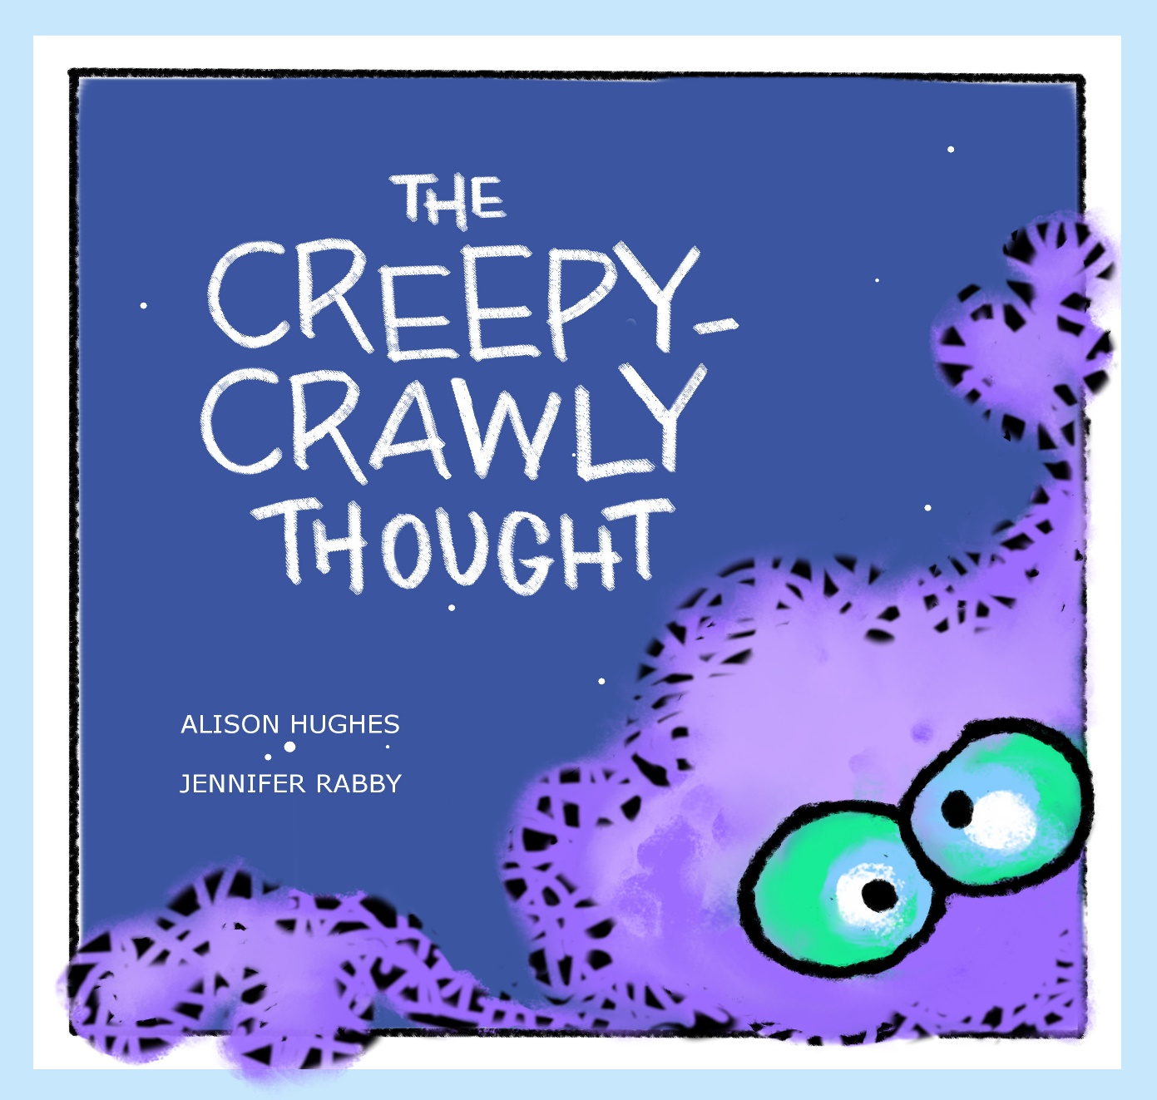

A Guide for Teachers

About The Creepy-Crawly Thought

When creepy thoughts slither in and refuse to leave, what can an anxious child do?

The Creepy-Crawly Thought answers with a wild, rollicking list of strategies to help chase bad thoughts away. Humor and rhyme tag-team with bold, fun illustration, empowering children to take charge and tackle their fears.

This timely story provides a gentle, humorous opening for talking with children about fears, anxiety, wellness and resilience.

About the Author and Illustrator

Alison Hughes and Jennifer Rabby are sisters who had a shared belief in this book and its usefulness in helping children talk about and overcome their fears. Thank you for using it to help the children in your life!

Author: Alison is an award-winning writer who has published 14 books for children and young adults. She has been a finalist for the Governor General’s Literary Awards, the Alberta Literary Awards, and the Silver Birch, among others. She was scared of natural disasters as a child, and still stockpiles canned goods. www.alisonhughesbooks.com.
Illustrator: Jennifer is a multi-media artist. The Creepy-Crawly Thought is her debut as a picture book illustrator. She was certain King Kong actually lived under her childhood bed, despite understanding that this was physically impossible. www.jenniferrabby.com.

Questions for Class Discussion

- Why do you think the author and the illustrator wanted to make The Creepy-Crawly Thought? (Hint: they were scared of things when they were children, too! They also wanted to help children talk about and conquer their fears.)

- Why do you think the author uses the phrase “creepy-crawly” to refer to scary thoughts? Look at the words she uses to describe them (slink, lurk, slither).

- Why do you think the creepy-crawly thoughts in the book aren’t in the shape of specific fears, like spiders or snakes? (Hint: it helps make the story more universal, and it brings up those fears and anxieties that aren’t clearly defined).

- In The Creepy-Crawly Thought, the creepy thoughts get worse at night. Is this a common experience? Do darkness, solitude and time for thought play a role?

- The girl’s thoughts in The Creepy-Crawly Thought are “shadowing her sunny mind.” What does this mean? Have the creepy thoughts scared her so much that she doesn’t feel like herself? Do they stop her doing things she usually does?

- Why do you think music might help to deal with creepy thoughts? Humor?

- Compare how the girl looks at the beginning of the book, with how she appears at the end of the book. What are the differences?

- The character in the book uses lots of strategies to take control of her scary thoughts, and eventually conquer them. What are some of the things we can do to do the same thing (e.g. Distract ourselves, get some exercise, spend time with family and friends, cuddle with pets, watch a fun show, etc.)
Childhood Fears – General Discussion

Children around the ages of four to seven, the target group for this book, experience many fears, including:
- The dark
- Bad dreams
- Natural disasters (e.g. Fire, tornado, flood, etc.)
- Monsters
- Bad guys / burglars / strangers
- Masks
- Animals (e.g. Snakes, spiders, dogs)
- Loud noises (e.g. Thunder)
- Being home alone
- Scary news, shows or movies
- Being injured, going to the doctor/dentist, getting shots
- Death (of themselves and of loved ones)
- School (including anxieties about grades, friends, fitting in)

Important points to emphasize:
- everyone has fears, even though they might differ person to person
- all fears are valid, and no fear should be minimized or ridiculed
- talking about fears and getting them out in the open sometimes makes them less scary
- if we bottle up fears, they sometimes become more frightening
- students can share their fears if they want or need to, or they can talk to the teacher or their parents or a caregiver privately
- it’s important to be supportive and reassuring when talking about fears
- children can all be empowered to take control of their fears
Suggestions for Classroom Activities

- Brainstorm a “Fears List” to work from, either verbally, or by suggesting the children write down or draw a fear and fold it up anonymously into a “Fears Jar.”

- Use drawing, stuffed animals, puppets and role-playing to look at and diffuse each fear (for example, you might do a role-reversal with a stuffed shark who is terrified of the class).

- Talk about how we feel when we’re scared (elevated heartbeat, breathing hard, shaky, cold, sweaty, ‘butterflies’ in the stomach, feeling sick) vs. how we feel when we’re happy.

- When a person is anxious or afraid, it helps to try to relax. Help the students with some relaxation techniques such as:
- Breathing (such as taking three big breaths, each deeper than the last, or using “petal breathing” where you open and close your fingers in time with your breath)
- Relaxation (mindfulness, music)
- Affirmations (“I am strong,” “I am brave,” “I am safe.”)
- Visualizations (such as puffy clouds gently floating across a blue sky)

- Research facts and information about animals or natural disasters that kids might find scary, to better understand them. This might shift the focus into making them objectively interesting or intriguing.

- Have the students think of things they were scared of when they were little, or what younger siblings might be scared of (these might include fear of water, loud noises, dogs). In a confidence-building exercise, note how they conquered those fears.

- Brainstorm a list of other strategies for dealing with fears, such as:

- blowing up balloons, drawing or writing their fears on them, and bopping them around the class

- writing out or drawing themselves with their fear with two speech bubbles: one fearful, the other positive, helpful and optimistic

- drawing silly pictures of the fears (e.g. A snake with a bow on its head)

- creating a ‘happy journal’ that could be opened and looked at when fears appear

- making a classroom chart with “Fearful thinking” on one side, and “Helpful thinking” on the other. Fearful thinking might include things such as ‘something bad is going to happen’, ‘I can’t do this,’ ‘I’m expecting the worst.’ Helpful thinking might include ‘I can do this’, ‘I am strong and smart and brave’, ‘I’ve got through things like this before,’ ‘things usually work out’, etc.

- coming up with a cheer (B-R-A-V-E! Watch out, fears, you can’t scare me!)

- making up a song or dance to chase bad thoughts away

- encouraging the kids to draw strength from strong characters (such as superheroes) they know or can imagine. How would they cope with fears?

- offering students the fun maze and coloring pages that follow!

