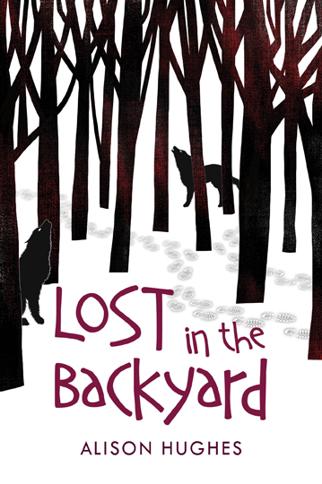

A Teacher’s Guide
Created by author Alison Hughes

About Lost in the Backyard

Summary:
Survival stories often feature hyper-resourceful kids who make and store pemmican, build log cabins and train wild falcons to hunt for them. This is not that kind of story. Flynn has no interest in the great outdoors, hates wet socks and loathes his Outdoor Education class. He’s a sarcastic, cool kid, glued to his phone when he’s not thinking about basketball. But when a walk in the woods leads him to being completely lost in the wilderness, can half a stick of gum, some moss and a handful of snow sustain him until he’s rescued? Join Flynn as he thrashes, flails and bleeds his way through long days (and worse – nights) in the forest.

Specifics:

Publisher: Orca Book Publishers (April 2015)
ISBN: 978-1-4598-0794-5
Ages: 9-12 (middle grade), 144 pages

Award nominations/designations:

- Sigurd F. Olson Nature Writing Award (SONWA) - Young Adult Notable Book (US) 2016
- Silver Birch Award (ON) 2016, nominee
- Diamond Willow (SK) 2016, nominee
- Hackmatack Award (Atlantic Canada) 2016-17, nominee
- Red Cedar Award (BC) 2016, nominee
- Ontario Library Association Best Bet 2016
- Surrey Schools’ Book of the Year 2016-17, nominee
- Ottawa Public Library One School One Book selection 2016

About the Author
Alison Hughes is an award-winning author who writes for children of all ages and for adults. When she's not writing, she presents at schools, volunteers with family literacy, and bikes in the river valley. She lives in Edmonton, Alberta, with her husband and children, where her three snoring dogs provide the soundtrack for her writing. For more information, visit her website at www.alisonhughesbooks.com or email her at alisonhughesbooks@gmail.com.

Other Books:

- Poser
- On a Scale from Idiot to Complete Jerk
- Gerbil, Uncurled
- Beatrice More Moves In
- Spare Dog Parts
- What Matters
- Kings of the Court
- Hit the Ground Running
- Kasey & Ivy
- Hide and Shriek
- The Silence Slips In
- The Creepy-Crawly Thought
- The Cold Little Voice
- Beatrice More and the Perfect Party
- Watch Out

How to Use This Guide

This Guide was created for teachers to use with their students in Grades 4-8. Teachers can, of course, select and adapt the activities to suit the age, interests and abilities of their students, their teaching style, and their curriculum requirements.

The teacher resources include novel study questions, activity ideas, a wildlife quiz, and a crossword puzzle. All the activities are intended to spark thought, discussion and debate about some of the issues raised in the book.

Thematic Links to Extend the Learning Process
- Survival
- Resourcefulness
- Resilience
- Strength in adversity
- Humour as a coping mechanism
- Nature/wildlife
- Outdoor education
- Family dynamics
- Decisions and consequences
- Coping with crises
- Taking control
- Overcoming obstacles
- Being alone/isolation
- Dependence on technology

Novel Study Questions

- There’s an old saying: “You can’t judge a book by its cover,” which means that we should go beyond appearances and look at the substance of some thing or person. But publishers realize that for most people, the cover of a book is a first impression which might influence a reader to take the book off the shelf. They take a lot of time having special designers craft book covers (it’s almost never the author). What do you think of the cover of Lost in the Backyard? Would a different cover have given you a different impression of the book (for example, a highly realistic, gritty cover image, or a stock image of a forest on a blue-sky day?)

- Flynn tends to cut corners and try to avoid schoolwork. Do you think the two books that he should have read for Outdoor Education might have given him some guidance when he gets lost? Some ideas? Some consolation? Are there things you have learned from books that have helped you in your everyday life?

- Flynn’s fear of nature is his downfall (quite literally). Do you think he really gave nature a chance when he stalked down that path? How better could he have coped with that first animal encounter? Do you think an appreciation of nature comes like a lightning bolt, or does it grow over time?

- Sometimes an appreciation for nature (or music or books) comes from being alone, being quiet and observing or listening. Our busy lives often don’t include quiet time. Flynn’s life certainly didn’t before he got lost, and he found the silence and solitude of the forest unnerving and even scary. Take a minute of quiet and observe how many sounds you hear, or how you breathe, or how you’re feeling. Do you have to be in the middle of the forest to find quiet time?

- Even though Flynn and Cassie are siblings, they are very different people. Flynn is cool and popular, Cassie quieter and less social. Cassie is capable and clever, Flynn less so. But Flynn’s respect for his little sister (and his parents) grows during his ordeal. Think of your own family or friend group, and how each of you are similar and different. How can we learn from and respect each other’s differences?

- Flynn doesn’t understand why Joe and Ellen have chosen to live off the grid, away from “civilization.” He judges them negatively, and sees his own way of living as the only way to live. Can you think of other ways people live that are misunderstood (e.g. People who are homeless, people with disabilities, refugees, etc)

- Flynn’s imagination about what could happen is often worse than reality. Has this ever happened to you? What are some calming strategies people use in anxious situations?

- Food, water, shelter – survival is as basic as it gets. But survival is mental as well. An important quality of Flynn’s is his resilience, or his ability to cope with setbacks, such as the helicopter non-rescue. Discuss situations where we need to be resilient in our everyday lives (such as bouncing back from a low mark, not making a team, not getting the part in a school play, etc.).

- Flynn feels completely alien to the forest and to the creatures who live with such ease within it. That feeling of being an outsider is a strange one for popular Flynn. Where do you feel most comfortable? Alone? With friends? At home? At school? Where do you feel like an outsider?

- Flynn looks pretty rough by the end of the book, and because he’s experiencing hypothermia, he’s acting (and feeling) very strange. What do you think the bus driver and the people on the bus thought of Flynn as he lurched onto the bus, and struggled to shove the bus ticket into the slot? What kinds of assumptions might they have made about him? What kinds of assumptions do we make about people who look or act differently?

- Do you think Flynn rescuing himself was a product of skill, perseverance, resilience or luck? Or some of all four?

- Do you think the forest is a character in the book?

- Do Flynn’s perceptions of the forest change or evolve during the story?

- What are the things that Flynn thinks about that make him keep going? What are the things you would think about to give you strength?

- It is challenging to write a story with only one character who is mostly alone. How would this book have been different (or better, or worse) if Flynn had been lost with another person?

- Notice the point of view of the story: it is told in the first person as if the reader is inside Flynn’s head. This was deliberate, so that the reader would be drawn into the story and feel they were right there with Flynn every step of the way. How would the story have been different if it was told by someone observing Flynn and describing what he does? What if it was told from the point of view of Cassie, or Flynn’s parents?

- While all fiction books have a setting, characters and a plot, sometimes one of those elements is dominant. The setting of the story (the forest) is a huge part of Lost in the Backyard. Discuss the way some other books are based more on character interactions, or around a gripping plot.

Activity Ideas

Activity 1: Short Story
Write a short story where a character (maybe you!) discovers something about themselves, their relationships or their beliefs (or all three) in the midst of a desperate survival situation.

Activity 2: Life-changing Decisions
In the book, Flynn’s parents’ decision to go to visit Ellen and Joe in their home off the grid has disastrous consequences. Write about a decision you made (or someone made for you) that changed the course of your day, your year, or even your life.

Activity 3: Map It
Draw an aerial map (a bird’s eye view) of Flynn’s trip out to Joe and Ellen’s house, and track his progress back toward the city through the forest. Include things like the highway, the forest, Joe and Ellen’s house, the ravine, the river, the place he encounters the bear, etc. You can include symbols, directions, arrows, or drawings of trees and wildlife.

Activity 4: Death and Dismemberment (and Zombies?)
School field trip forms are designed to limit the school’s legal responsibility for anything that goes wrong. That’s why they list so many awful things that almost never happen (but could).
In this activity, you’re in charge of the school field trip. Write the form that is sent home to parents. Remember to think of everything that could realistically go wrong, bearing in mind the activity you’ve chosen. Alternatively, you could create a fantasy field trip form, warning of troll attack, zombie apocalypse, etc.

Activity 5: Create a Graphic Chapter
Pick one chapter of the book and create a graphic novel format for it.

Activity 6: You be the Designer
Design a new cover for the novel. Why did you draw what you drew? What did you hope to convey to someone who has never read the book?

Activity 7: The Wild Life
Research the animals that live in the wild in your area. How can you enjoy nature while giving them space? What should you do if you encounter them?

Activity 8: Can I eat that?
Research the plants and berries in your local environment. How many of them are poisonous? Which ones could you eat?

Activity 9: Old-School Mapping
What if you couldn’t access the Internet or a GPS? Make an old-school, hand-drawn map of your school in relation to its neighborhood and any natural landmarks. Or go on a class hike and draw a map of where you went.

Activity 10: Teamwork and the Rule of 3

Survival research shows that in extreme conditions, a person can survive for three minutes without air, three hours without shelter, three days without water, and three weeks without food. In groups, choose and develop one of these scenarios to figure out how using teamwork and cooperation can help to beat the odds.

Activity 11: Make Some Noise!

On a hike in the woods, it’s best to make a lot of noise so animals know you’re there. It’s the best way to avoid animal encounters. You can make a simple noisemaker out of everyday materials.

Materials
- Empty soda can
- 5 coins
- Duct tape
- Aluminum foil
Directions
- Put the coins in the can and seal with duct tape.
- Cover the can in foil, and seal the edges with duct tape.
- Carry this on a hike, shaking it as you walk; the foil is reflective, which is another way of alerting animals.

Lost in the Backyard:
A Semi-Serious Wildlife Quiz

Flynn in Lost in the Backyard is terrified of anything that moves. He doesn’t do a lot of things right, but he’s actually correct in giving wildlife its space. Wild animals, even plant-eaters, can be dangerous and unpredictable, and should never be approached or fed. All wildlife is wild, an obvious fact that people often forget. It is best to enjoy nature in a group, and to warn wildlife of your presence by making noise. Most animals want to avoid encounters.

The following semi-serious quiz is just a start to thinking about wildlife encounters. There are lots of resources out there to do further research. A good start is Parks Canada’s Keep the Wild in Wildlife booklet at http://www.pc.gc.ca/eng/docs/pc/guide/nature/nature01.aspx.

QUIZ

- A porcupine waddles across your path. You should:
- See if it will come closer with a “here, kitty, kitty, kitty!” call.
- Remember that porcupines only like being petted one way: from the head down and not from the tail up.
- Don’t alarm it, back away and give it lots of space.

- You see a moose in the forest. You should:
- Figure out how to ask your Mom for one, because you’ve never had a pet moose.
- Try to get close enough to feel the horns to see if those huge things are actually real.
- Walk away quickly and put distance and obstacles like trees between you and the moose.

- You come across a little black bear cub on a hike. You should:
- Give it a quick cuddle because it looks lonely (and it’s the cutest thing you’ve ever seen!)
- See if it will eat the granola bar or sandwich in your backpack.
- Leave it alone and get out of there quickly, because the mother bear is likely around. If you encounter her, keep calm and back away, leaving her and the cub plenty of space to leave.

- You surprise a deer when you’re hiking through the forest. You should:
- Try to get close enough to get a selfie so you can show your friends.
- Make sure you pet it, because you know for a fact that deer won’t eat you.
- Avoid approaching and startling the deer, give it space and allow it to leave.

- You’re out walking your tiny, fluffy dog Fifi. You see a coyote (or a wolf; you’re not sure). Fifi starts yipping at it. You should:
- Wait to see if Fifi and the animal make friends, and this will give you time to figure out if it’s a coyote or a wolf.
- Say “who’s a good boy?” calmly, while tossing out Fifi’s treats.
- Immediately pick up Fifi, make yourself as big as you can, yell and throw sticks and stones to scare it away.

- Your chances of meeting a cougar are rare, but if you do, you should:
- Relax and remember that it’s just a big kitty-cat, not so different from the pet cats you have at home.
- Reach for your phone and send an “OMG, looking RIGHT at a COUGAR!” text.
- Back away slowly (do not turn and run), maintain eye contact, arm yourself with sticks and rocks to throw, and try to appear as big and as loud as you can.

- You’re camping with your family. After roasting hot dogs over the campfire you:
- Chuck the scraps on the ground. It’s not really littering, because the animals will eat them, right?
- Figure you’re pretty tired, so you’ll all do the dishes in the morning.
- Put all garbage in bear-proof bins or in a hard-sided vehicle, wash dishes and clear away all traces of food.

- Walking around a lake, you come across a group of elk. You:
- Clap loudly, because you’ve never seen an elk stampede and it would make a great video.
- Mimic the big elk’s bugling sound, because it sounds hilarious.
- Walk away, keeping an eye on the elk, and putting lots of space between you and them.

- You are startled as a snake crosses your path. You:
- Try to catch it to see whether or not it’s poisonous.
- Try to remember a few words of Parseltongue from Harry Potter so you can communicate with it.
- Leave it alone and let it get as far away as it can.

Copyright Alison Hughes 2015

LOST IN THE BACKYARD CROSSWORD
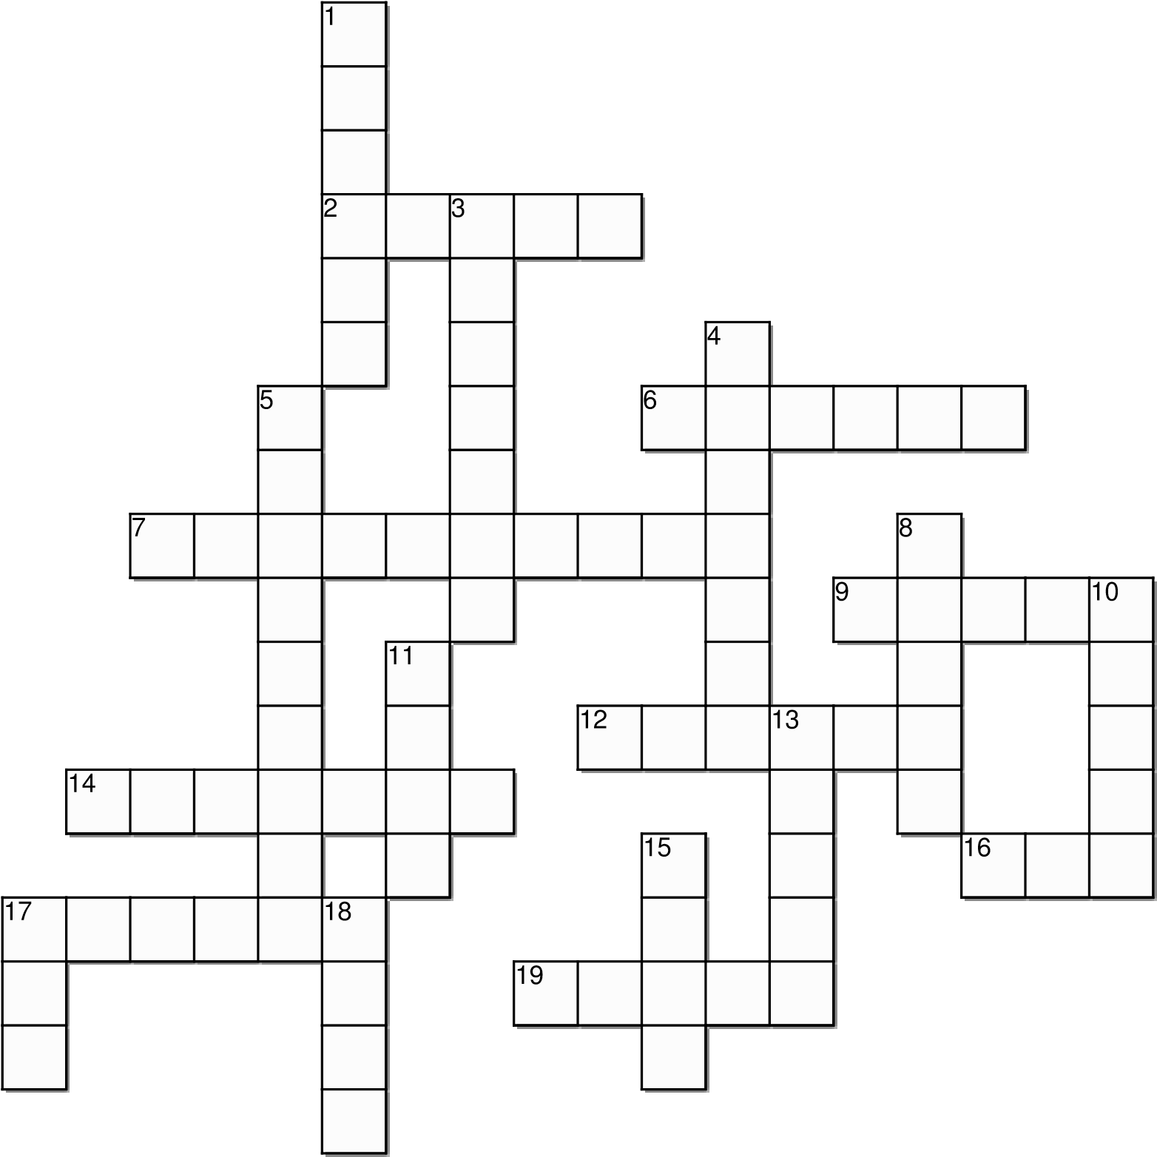

Across
2. Flynn is injured, but he can’t stand the sight of _____.
- To get warmer, Flynn stuffs his coat with these.
- Flynn desperately tries to signal to a rescue ______.
9. The scariest time to be alone in the forest.
12. Flynn’s sister.
14. Howling: wolves or ______?
- When he stumbles out of the woods, Flynn almost gets hit by a ____.
- Thankfully, Flynn’s mother kept a pair of these in her fleece pocket.
- Flynn looks up and wishes on these.

Down
1. Flynn surprises two of these creatures, who hop away.
- Flynn’s least favourite class is _____ Education.
- Birds eat these, but can Flynn?
- Flynn keeps reaching for this, but the battery is dead.
8. Flynn’s big mistake was crossing the _____.
- When his phone is charged, Flynn has 216 of these.
- These creatures introduce Flynn to eat n’ go moss.
13. If there's one thing Flynn hates, its wet ____.
15. Flynn scares off this large (and scary) animal.
- Half a piece of ____ never tasted so good.
- A good substitute for a glass of water

Lost in the Backyard Writing Prompt: “Backpack Survival”

In Lost in the Backyard, Flynn has very little to help him in his ordeal: a dead cellphone, a thin pair of gloves, a half piece of gum, a coffee stir-stick, and a bus ticket. He finds a way to use all the items in some way.

Find three items in your backpack (not including your lunch or water bottle) or your desk that could help you if you were completely stranded in the woods. Explain why you chose each item, how it could help you, and what you would use it for. Be creative!

Item #1: ____________________________

______________________________________________________________________________________________________________________________________________________________________________________________________________________________________________________________________________________________________________________________________________________________________________________________________________________________________________________________________________________________________________________________

Item #2: _____________________________

______________________________________________________________________________________________________________________________________________________________________________________________________________________________________________________________________________________________________________________________________________________________________________________________________________________________________________________________________________________________________________________________

Item #3: _______________________________

______________________________________________________________________________________________________________________________________________________________________________________________________________________________________________________________________________________________________________________________________________________________________________________________________________________________________________________________________________________________________________________________

Lost in the Backyard – Writing Prompts
Beyond your Body: Survival Starts in the Mind

Success in survival can be determined by a number of things including skill and luck. But many survival experts say that much of survival is psychological. A psychological force called “the will to live” leads many people to draw strength, hope, resilience and determination from within themselves to survive against even the worst odds.
In Lost in the Backyard, Flynn’s will to live is strengthened by thoughts of his sister, parents and friends, and even by his position on the school basketball team. Write a paragraph about the people, interests and connections that would give you strength to go on if you were in a desperate survival situation.
_____________________________________________________________________________________________________________________________________________________________________________________________________________________________________________________________________________________________________________________________________________________________________________________________________________________________________________________________________________________________________________________________________________________________________________________________________________________________________________________________________________________________________________________________________________________________________________________________

At first glance, Flynn doesn’t have many qualities that are useful in a survival situation. He has no outdoor skills, he’s not handy, he’s easily scared, and he’s not particularly brave. But he’s observant, resourceful, athletic and surprisingly determined. And sometimes an emergency situation is where people discover qualities about themselves they never knew they had.
What qualities do you have that would help you survive? __________________________________________________________________________________________________________________________________________________________________________________________________________________________________________________________________________________________________________________________________________________________________________________________________________________________________________________________________________________________________________________________________________________________________________________________________________________________________________________________________________________________________________________________________________________________________________________________________________________________________________________________________________________

Write a short story where a character discovers something about themselves, their relationships or their beliefs (or all three) in the midst of a desperate survival situation.

